**Connect to Azure DevOps using GIT**

1. Download **Git** from the url: <https://git-scm.com/download/win>

1. Install it in your machine. Refer <https://www.toolsqa.com/git/install-git-on-windows/> on how to install.
2. After the GIT installation, open command prompt and type **ssh-keygen -C "yourmailid"**

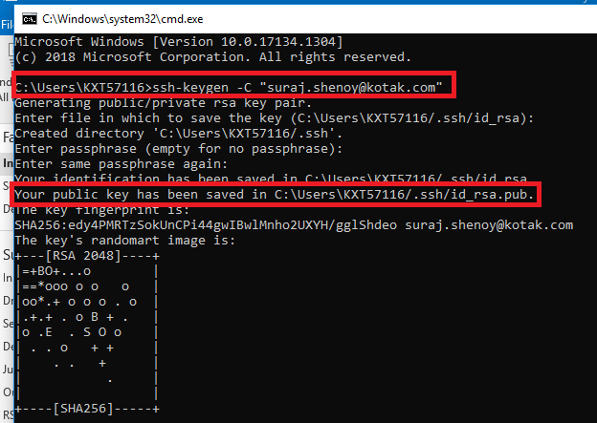

1. Open the public key location which is mentioned in the command prompt. **Copy** it.
2. Open Azure DevOps home page. In the home page open user setting and choose **SSH Public Keys**.

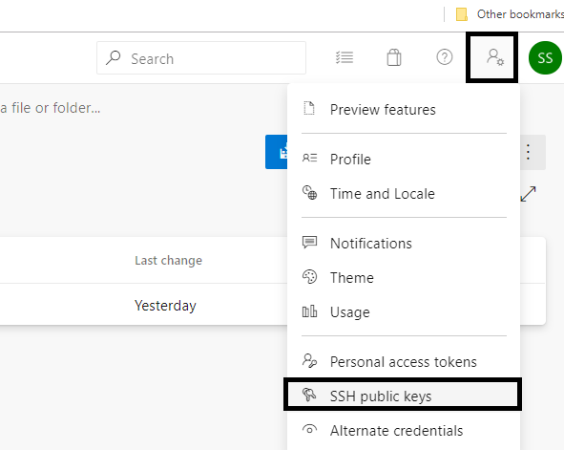

1. Then click on **New key** option available on right top.
2. Provide any name. Also, paste the copied public key data and create. (copied in step 4)

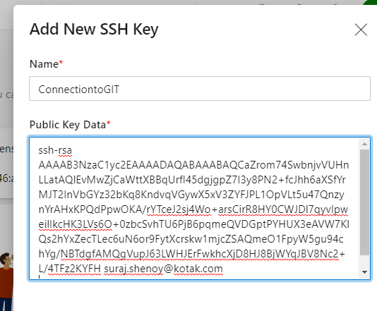

1. Once created, clone the repository using **SSH** URL. To get it, first click on clone option in Azure DevOps

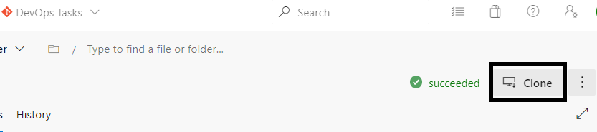

1. Select **SSH** option in clone section and copy the SSH URL.

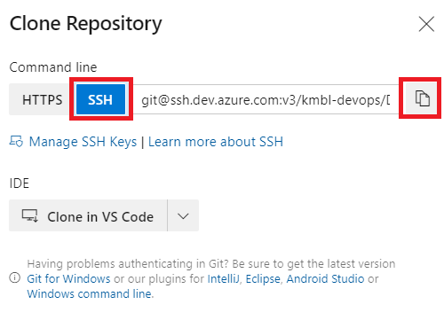

1. Then, use the command prompt to clone the repository. Use command **git clone “copied url”.**

**E.g.:** git clone[git@ssh.dev.azure.com:v3/kmbl-devops/DevOps%20Tasks/DevOps%20Tasks](mailto:git@ssh.dev.azure.com:v3/kmbl-devops/DevOps%20Tasks/DevOps%20Tasks)

1. You can perform modifications in the same folder once it gets cloned.
2. Later use the git commands to push your code to the Azure Repos.

**E.g.:** git add . (to add your changes to the staging area)

git commit –m “enter the commit message” (to commit changes)

git push (push the changes to server)

To know more on GIT usage you can refer: <https://dzone.com/articles/git-tutorial-commands-and-operations-in-git>